**Project report On**

**Mental Health in Tech Survey**

**(2014-2020)**



Symbiosis Institute of Geoinformatics (SIG)

**(Symbiosis international University)**

**SUBMITTED BY -**

**Nisha Pagare (20070243017)**

**Piyusha More (20070243015)**

**Vinay Wadhwa (20070243018)**

**Aadhiban S J (20070243040)**

**Girish Narsinghani (20070243041)**

Index

|  |  |  |
| --- | --- | --- |
| SR NO | Topic | Page No. |
| 1 | Abstract | 3 |
| 2 | Preface | 4 |
| 3 | Acknowledgement | 5 |
| 4 | Flowchart | 6 |
| 5 | Description of Data and methodology  1 - Data cleaning  2 – Data processing  3 – Data Analysis  4 – Data Visualization | 9 to 23 |
| 6 | Tableau Analysis on Survey | 24 to 26 |
| 7 | Covid methodology and survey analysis | 27 to 31 |
| 8 | Impact of covid-19 | 32 |
| 9 | Discussion and Overview of mental health:  1 - Mental health Disorders -  2 - How to Tech help in Improve mental health | 33 to 37 |
| 10 | Description of survey | 41 |
| 11 | Role of policy recommendation –  1 – Mental health policy needs to be generic health policy | 47 |
| 12 | Conclusion | 51 |
| 13 | Reference | 52 |

**Abstract**

The project is undertaken at Symbiosis institute of Geoinformatics, Pune has the Protentional of giving a visually better and more clear understanding of in the world What is today’s situation on Mental health then how can we improve mental Illness into Technology.

The project talks about Mental Health in Tech survey using 2014 performed by non- profit Organization Open-Source Mental health, this Report is seeking to examine the difficulties faced by tech sector employees, Children, family, society when dealing with mental health, illness issues. Today’s current situation because of Covid-19 virus in the year 2020 during the lockdown, we recognize that people affected or some people stuck by mental illness they are dealing with Covid – 19.

The project’s main objective is to collect the data from insights in different Country, help to reduce the mental health problems And How the Technology help in the mental and emotional health to reduce and enhance our health.

**Preface**

Mental health is gradually increasing and affect daily living, relationship and physical health. Such conditions such as stress, depression, and anxiety can all affect mental health and disrupt a person’s routine. Social and financial circumstances, biological factors, and lifestyle choice they all shape a person’s mental health. In this project we trying to show survey through how practically acknowledging mental health issue out in the open, which is exactly todays for our society, the present survey is conducted by OSMI volunteers who had spent their time to doing in such activities. The covid-19 during lockdown, had a negative impact on physical as well as mental health. People are afraid of dying, of losing their loved ones, they feel too alone, their jobs are losing etc, reason of internal migrant workers in India the entire nation was the victim of stringent measures to spread of corona Virus in the form of travel restriction and lockdowns. this survey conducted by Telephonic interviews. To find out their health issues.

So, on such conditions like how to treat, how to improve or enhance from such disorders. The use of technology in treatment of mental disorders, technology like virtual reality, computer programs, social media, video games etc. these technology help to improve in mental illness and health.

This is main idea behind making this project is to detect and predict the Mental health and illness.

**Acknowledgment**

We are thankful to receive assistance from one person in making this project success.

We take this opportunity to express our deep regards and gratitude towards **Mrs. Aparna Joshi** (professor) for supporting us throughout the completion of the project.

We would like to express our gratitude towards our parents for their kind cooperation and encouragement which helped us in completion of this project.

Without your help, we surely will not be able to complete this project. Thank you so much ma’am for helping us during rough and tough times.

**Flowchart Diagram -**

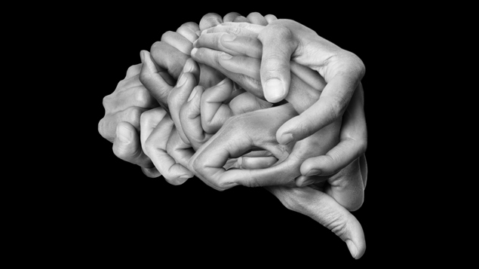

**Introduction**

Psychological wellness isn't only the shortfall of mental Disorder. It is characterized as a condition of prosperity in which the people understand their own capacities, can adapt to the typical burdens of life, can work gainfully and productively, and can make a positive commitment to their local area.. Psychological state is concerning enhancing competencies of people communities and sanctionative them to attain their self-determined goals. Here unique dataset was constructed during the pandemic when the entire nation was the victim in the pandemic situations from of travel restrictions and lockdowns. We also collected the data in our pursuit to submit paper in response to call for paper in the journal titled “Migration and Health”. The interview schedule was adopted by Using CAS (Corona virus Anxiety Scale) which uses four-dimension model namely cognitive, emotional, Behavioural and Psychological.

Mental health issues have an effect on society as an entire, and not simply a little, isolated section; they're thus a serious challenge to international development. No cluster is proof, against mental disorders; however, the chance is higher among the poor, homeless, the idle, persons with low education, victims of violence, migrants and refugees, autochthonic populations, kids and adolescents, abused girls and therefore the neglected older. For all people, mental, physical and social health’s are closely interlocking, very important strands of life.

As our understanding of this mutualistic relationship grows, it becomes ever a lot of apparent that mental health is crucial to the general well-being of people, societies and countries. Sadly, in most components of the globe, psychological state and mental disorders aren't accorded anyplace an equivalent importance as physical health. Rather, they need been mostly unheeded or neglected. Stigma is when someone views you in a negative way because you have a distinguishing characteristic or personal trait that's thought to be, or actually is, a disadvantage (a negative stereotype). Stigma can lead to discrimination. Discrimination may be obvious and direct, such as someone making a negative remark about your mental illness or your treatment. Or it may be unintentional or subtle, such as someone avoiding you because the person assumes you could be unstable, violent or dangerous due to your mental illness

**Common Mental Health Terms**

addiction is a persistent cerebrum illness that causes urgent substance use regardless of unsafe resultso alcohol and substance use issues allude to the abuse of liquor or medications prompting impacts that are impeding to the person's physical and psychological well-being, or the government assistance of others

o bipolar jumble, likewise ordinarily known as hyper sorrow, is a cerebrum issue that causes shifts in an individual's mind-set, energy and capacity to work

o depression is a typical and genuine clinical sickness that causes sensations of pity and additionally a deficiency of interest in exercises once appreciated; it can prompt an assortment of passionate and actual issues

o eating messes are sicknesses in which individuals experience extreme aggravations in their eating practices and related contemplations and feelings; anorexia nervosa, bulimia nervosa and gorging jumble are the three fundamental sorts

o Obsessive-Compulsive Disorder (OCD) is a tension issue where individuals have repeating, undesirable contemplations, thoughts or sensations (fixations) that cause them to feel headed to accomplish something monotonously (impulses)

o Compost Traumatic Stress Disorder (PTSD) is a mental problem that can happen in individuals who have encountered or seen a horrible mishap like a cataclysmic event, a genuine mishap, a psychological militant demonstration, war/battle, assault or other fierce individual attack.

**Data Collection and Methodology**

The dataset of Mental health survey 2014 was conducted by Open Sourcing Mental Illness (OSMI).

The Volunteers are – ED Finkler, Jennifer Akullian , Joe Fergusson

The survey was conducted online at the OSMI website and the OSMI team intends to use these data to help drive awareness and improve conditions for individuals with mental illness in the IT workplace. It should be noted that as this is an online survey, it may be prone to voluntary response bias and may cause over representation of data. The sample of respondents was not obtained through any random sampling approach.

Keeping the above limitations in mind and being cautious with our interpretations, we have use the data to gain some insight into the state of mental health in the tech workplace.

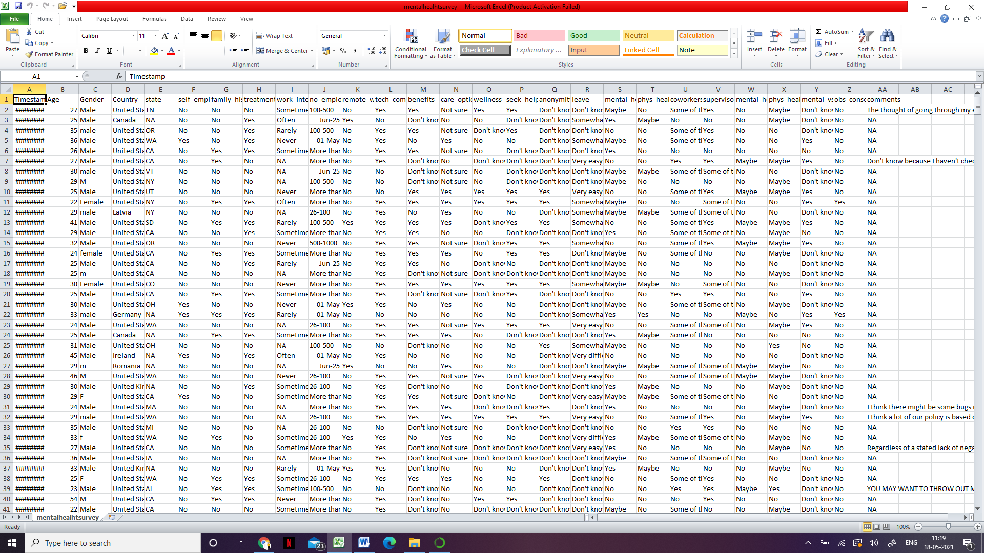

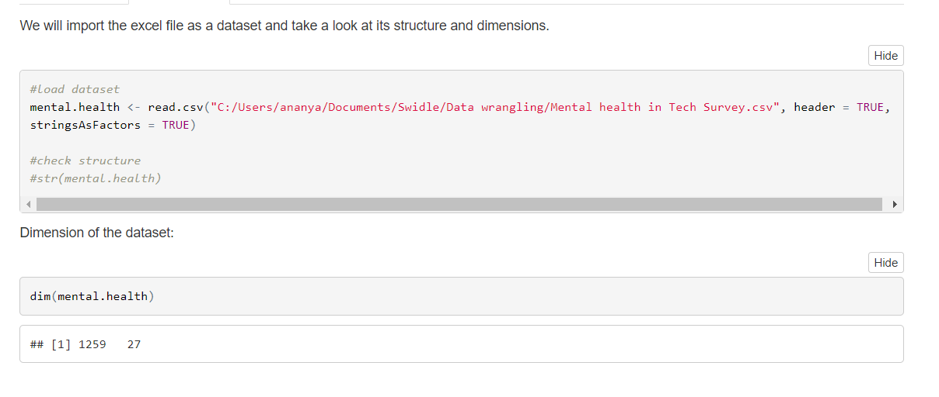

**Data Description –**

The dataset contains 900 rows with responses of people who participated in Survey. This survey examined people based on 27 factors (columns) that might associate with the mental health status.

This dataset contains the following variables:

* **Timestamp**
* **Age**
* **Gender**
* **Country**
* **State**: If you live in the United States, which state or territory do you live in?
* **Self-employed**: Are you self-employed?
* **Family history**: Do you have a family history of mental illness?
* **Treatment:** Have you sought treatment for a mental health condition?
* **Work interferes**: If you have a mental health condition, do you feel that it interferes with your work?
* **Number of employees**: How many employees does your company or organization have?
* **Remote work:** Do you work remotely (outside of an office) at least 50% of the time?
* **tech_company**: Is your employer primarily a tech company/organization?
* **Benefits**: Does your employer provide mental health benefits?
* **Care options:** Do you know the options for mental health care your employer provides?
* **Wellness program:** Has your employer ever discussed mental health as part of an employee wellness program?
* **Seek help:** Does your employer provide resources to learn more about mental health issues and how to seek help?
* **Anonymity**: Is your anonymity protected if you choose to take advantage of mental health or substance abuse treatment resources?
* **Leave:** How easy is it for you to take medical leave for a mental health condition? Mental health consequence: Do you think that discussing a mental health issue with your employer would have negative consequences?
* **Physical health consequence**: Do you think that discussing a physical health issue with your employer would have negative consequences?
* **Co-workers**: Would you be willing to discuss a mental health issue with your co-workers?
* **Supervisor:** Would you be willing to discuss a mental health issue with your direct supervisor(s)?
* **Mental health interview:** Would you bring up a mental health issue with a potential employer in an interview?
* **Physical health interview**: Would you bring up a physical health issue with a potential employer in an interview?
* **Mental vs physical:** Do you feel that your employer takes mental health as seriously as physical health?
* **Observed consequence:** Have you heard of or observed negative consequences for co-workers with mental health conditions in your workplace?

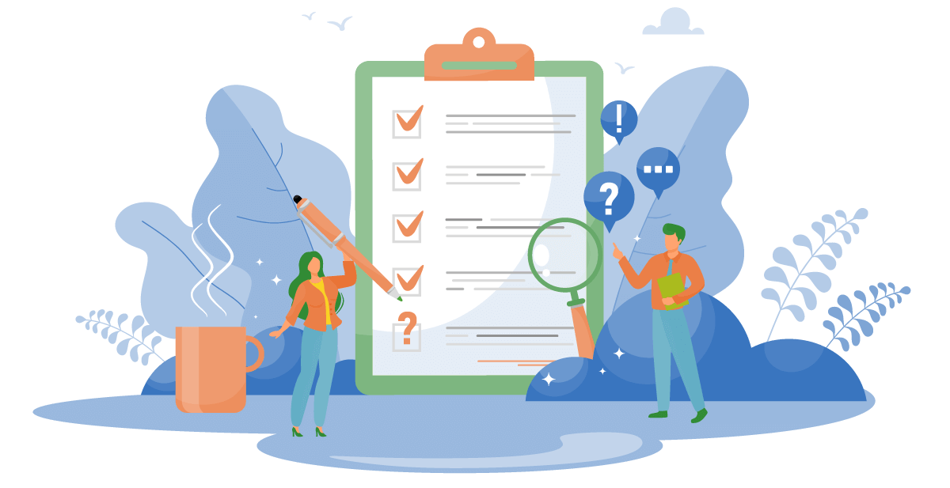

**DATA PREPROCESSING:**

The tool python was used for data pre-processing and cleaning purpose. In python there are different packages but, in this project, we mainly used pandas and NumPy for data cleaning processing. We use these packages to remove the unwanted fields. We check this by looking into the dataset and finding the fields which has a lot of non-available entries. By this we remove the field “timestamp”, “state”,” comments”. Later we find a lot of cleaning process to be executed in the gender field. The below mentioned are the different word cloud to mention different entries mentioned in gender and we categories them into male, female and transgender.

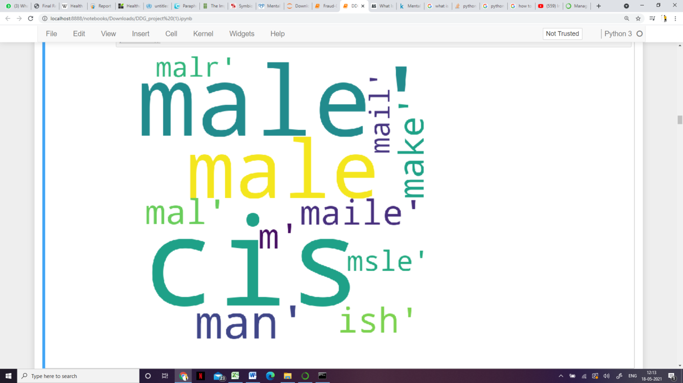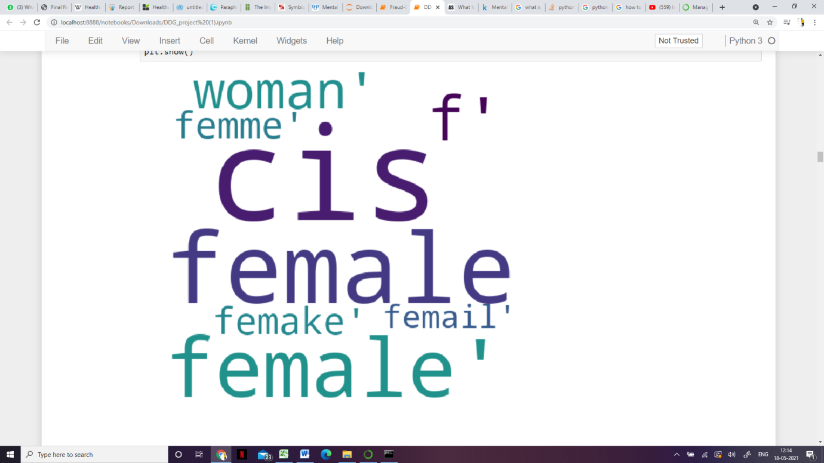

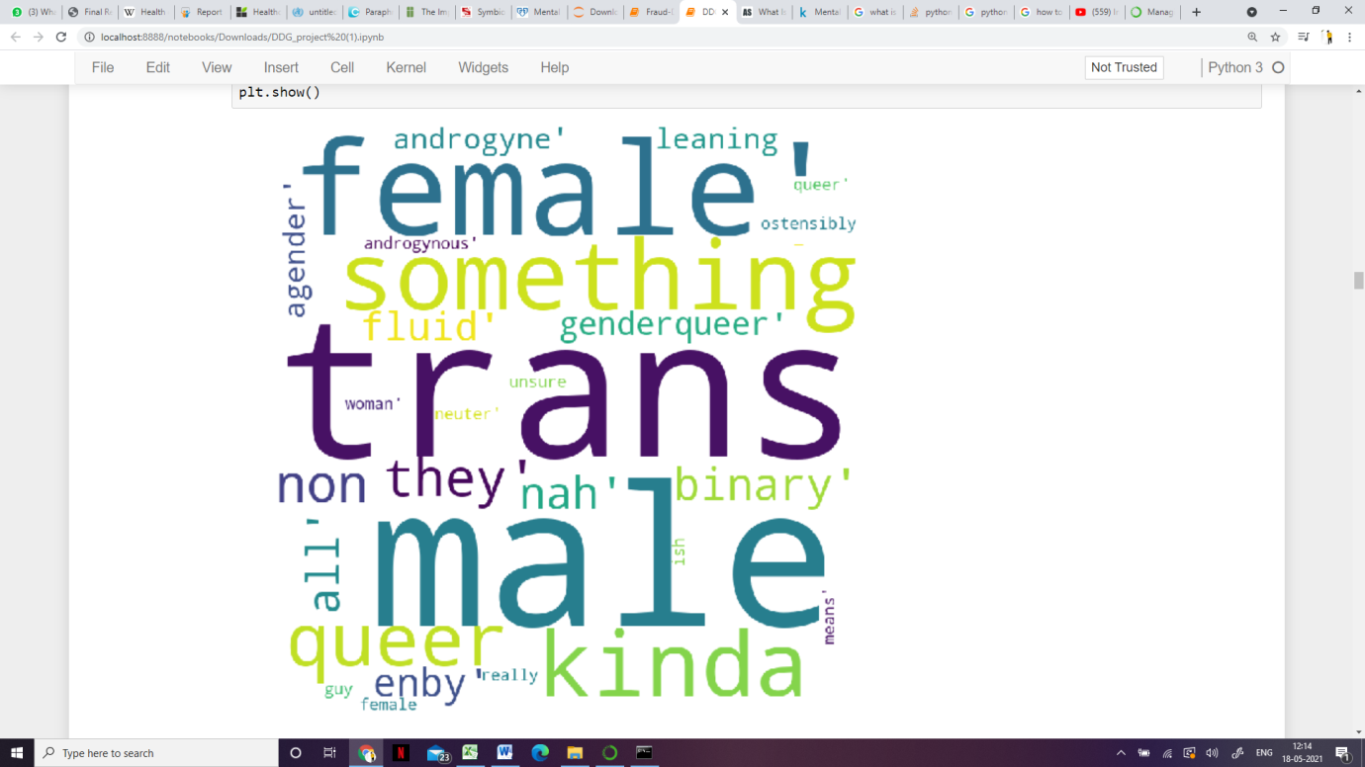

**Data Cleaning-**

The first part of data cleaning involves cleaning up of the Gender variable. Based on the responses, there are 49 unique entries of gender. We will divide these values into four main categories: Male, Female, Gender Queer and Transgender.

If we check for missing values in the dataset, we observe that most of the missing values are in the comment’s variable. A few missing values are also present in the “self-employed” and “work interfere” variables. As these are categorical variables, it is difficult to impute the missing values for these variables. Hence, we will retain these variables until the EDA phase and then decide if we need to retain or drop them.

Table with count of missing values:

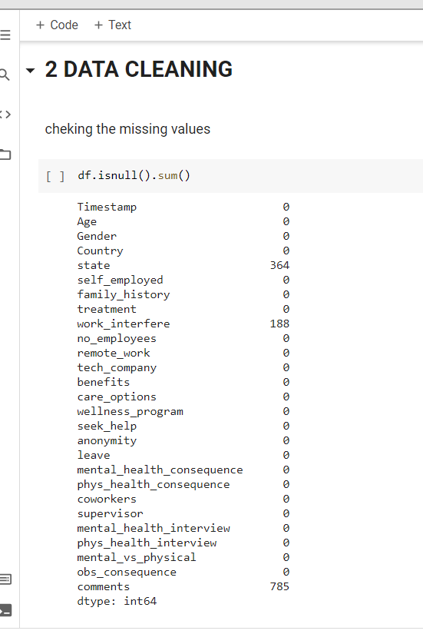

Later, while looking into the dataset we found that there is lot of errors in gender column so we clubbed them according to male female and trans-gender as shown below:

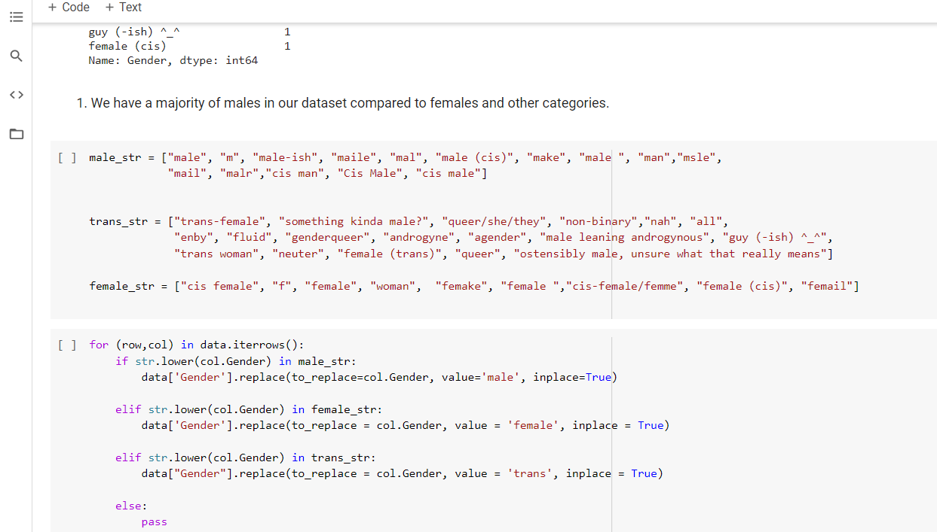

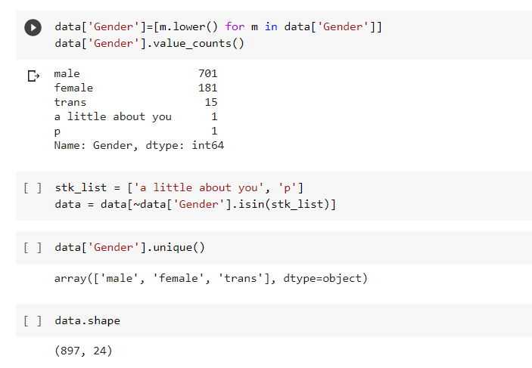

**Data Analysis -**

We tried to understand the dataset and gather knowledge from the study, we used three fields from the dataset “treatment” which is our label and the features “remote work” and “Self-employed” with respect to countries.

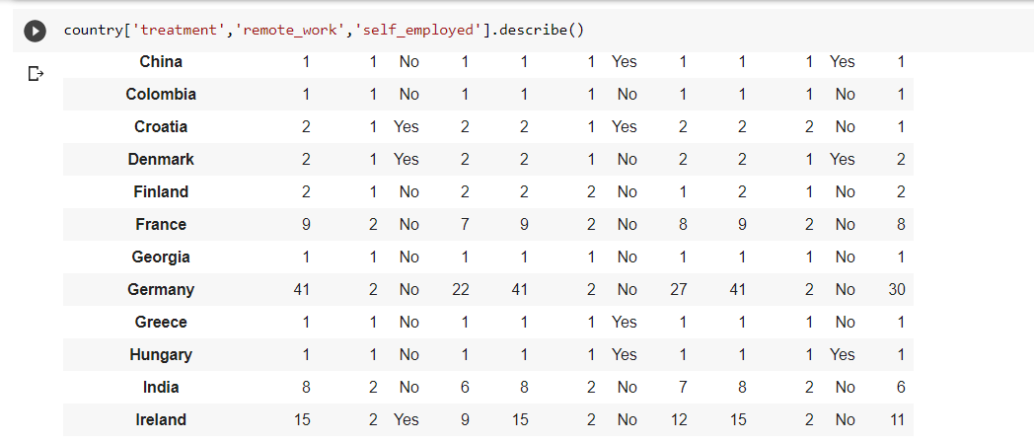

Later we try to find the relation between the label “treatment” with the feature “age” and we also try to find the relation with the features of “self-employed” and then clubbed relationship between “treatment” and “Tech Company” and “work interface”

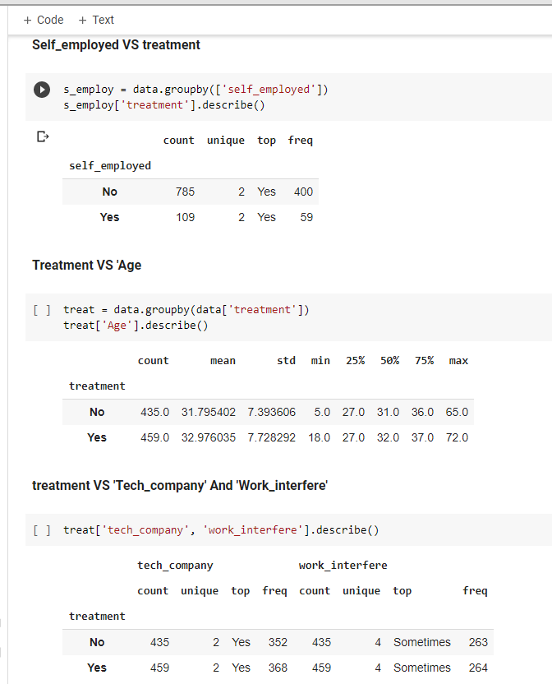

1. Physical Health issue with a potential employer in an interview

In the below image we show how the survey ranges for the question asked whether the question of physical illness is asked and then we normalise the answers

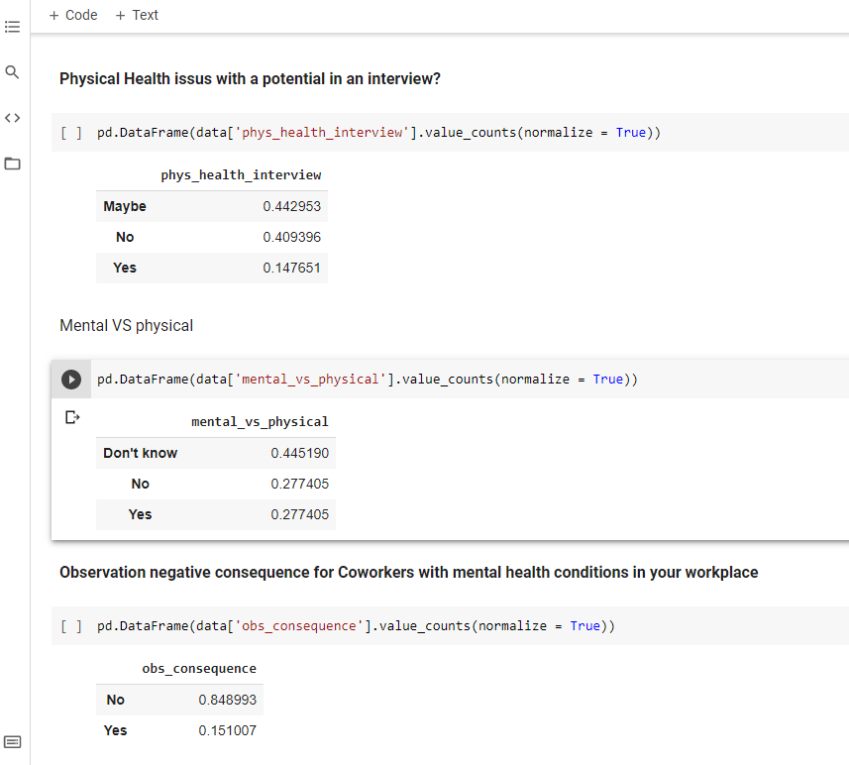

There are 40% they don’t share their physical health issues.

There are 14% they share their physical health issues.

We can see the most of the employee who attend the interview with the question of physical illness tend to neglect the question.

The below figure shows the comparison to show whether the person takes the mental illness seriously as he takes physical health



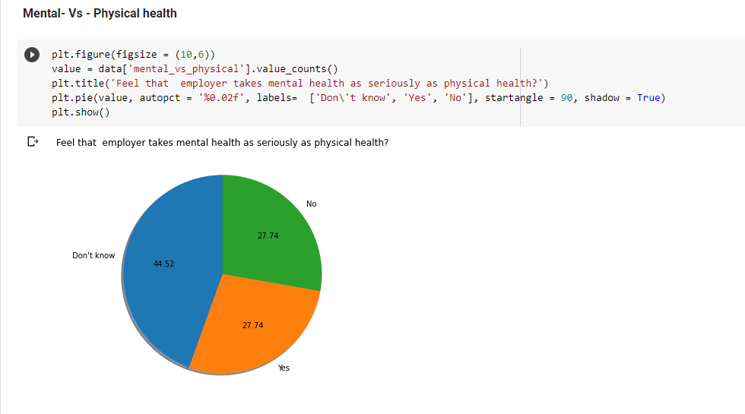

From the above analysis we can see that the ratio of the seriousness of mental illness compared to physical illness is same but we know that mental illness has more severe consequences than physical illness.

The below image shows the thoughts of people, like how they think does taking a mental illness treatment affects their working time.

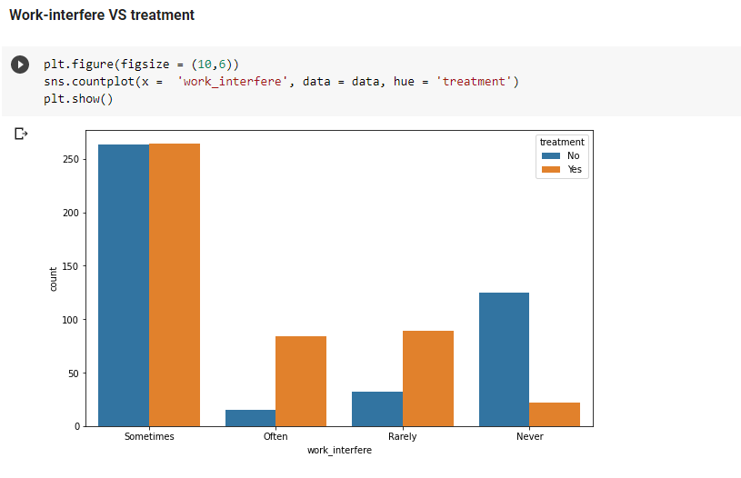

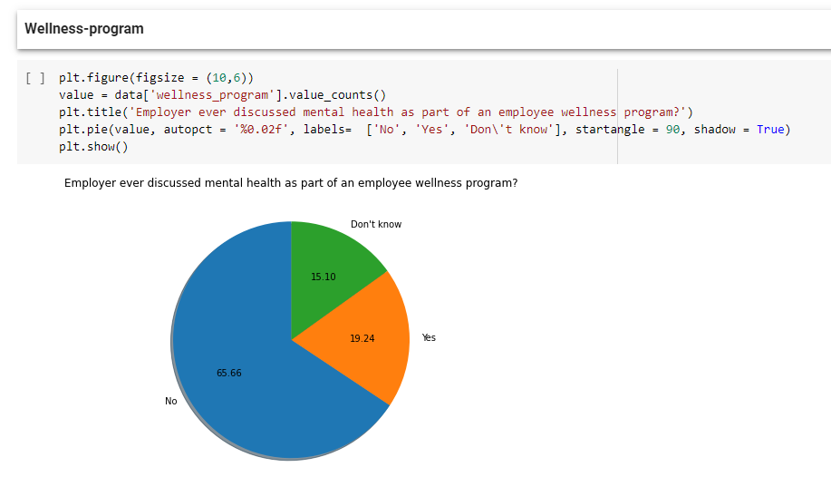

The second model introduces control that account for employee demographics. The explanatory independent variable’s p-value increases drastically rendering it statistically insignificant in this model. The p-values for the variables asking whether an employee has sought treatment for a mental health condition and if they have a family history of mental illness both indicate that they are highly significant. The p-values for the variables indicating if an individual is self-employed and if they work remotely at least 50% of the time both indicate that these are not statistically significant factors in influencing whether an employee thinks they will face negative consequences when raising mental health issues to their employer or not.

1. To observe negative consequences for Co-workers with mental health condition in workplace.

There 85% people don’t have negative consequence on mental health

15% people have negative consequence.



**Data Visualization –**

Country-wise representation of data with focus on India Gender ratio

participating in the Survey

There are a greater number of males are working in tech companies all over the world

**The country wise representation of data with focus on India.**

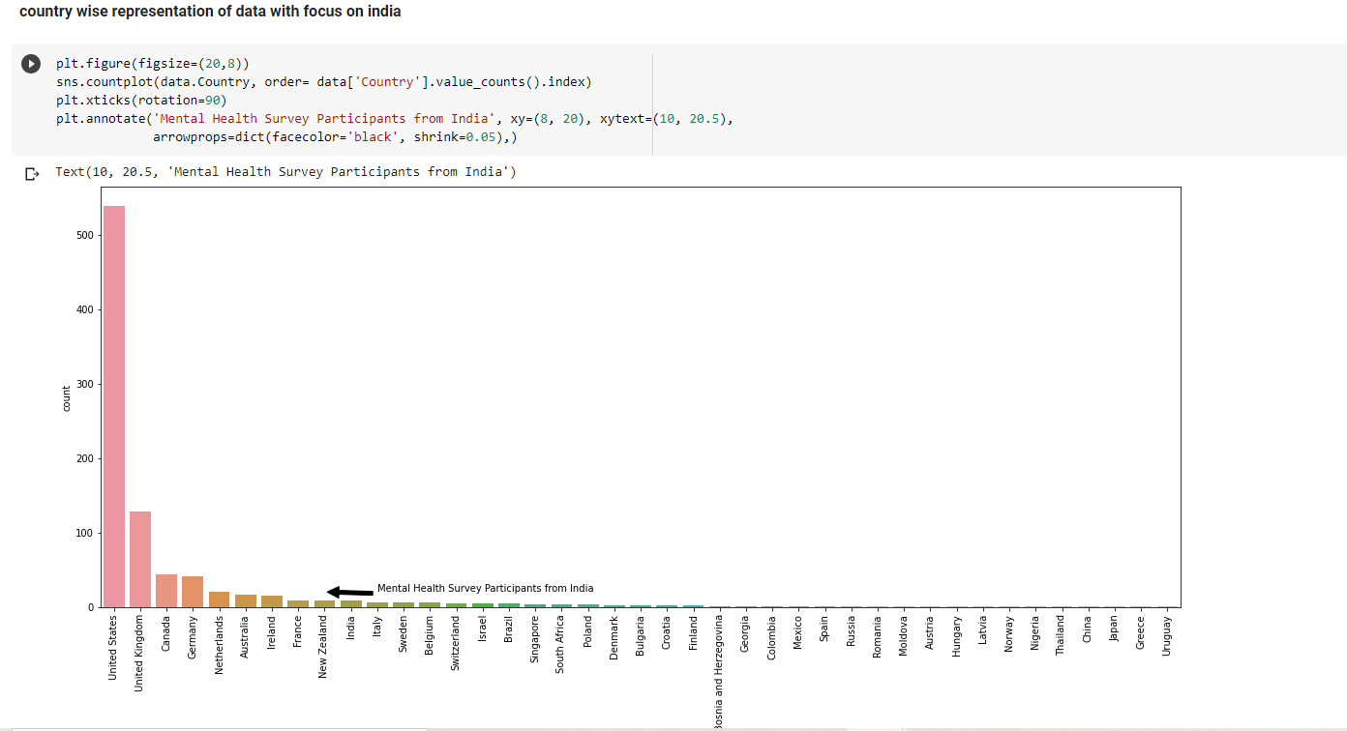

To visualise the anonymity of the individual in area of mental illness and how often does the employee gets leave due to mental illness

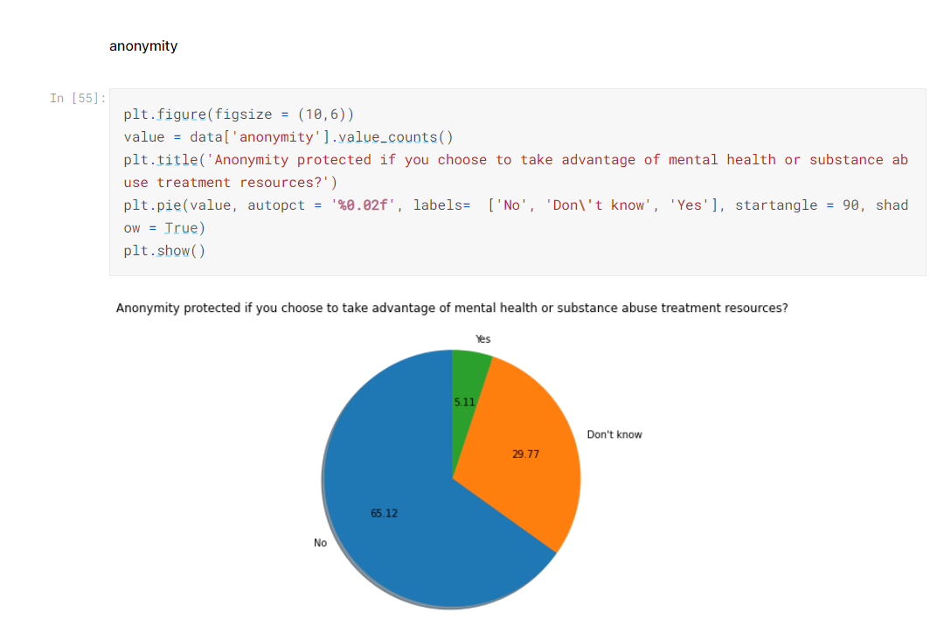

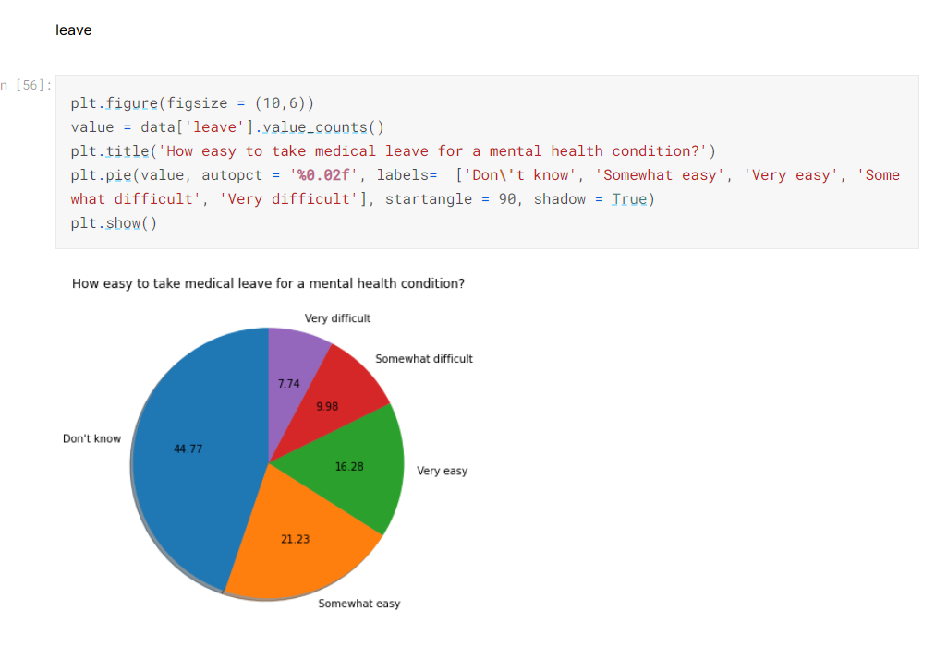

Observing the model below employee thoughts on facing negative consequences when raising mental health issues to their employer. The first model in this set of stepwise logits, employees that work for a primarily technology-oriented company or organization, on average, have a 14 % higher probability of thinking they will face negative consequences when discussing mental health issues with their employer.

Without introducing any controls, the p-value for the main independent indicates a highly statistically significant difference between those who work for a technology company or organization and those who don’t with regards to the thought of facing negative consequences when discussing mental health issues with their employer.

14 % yes and 85 % no

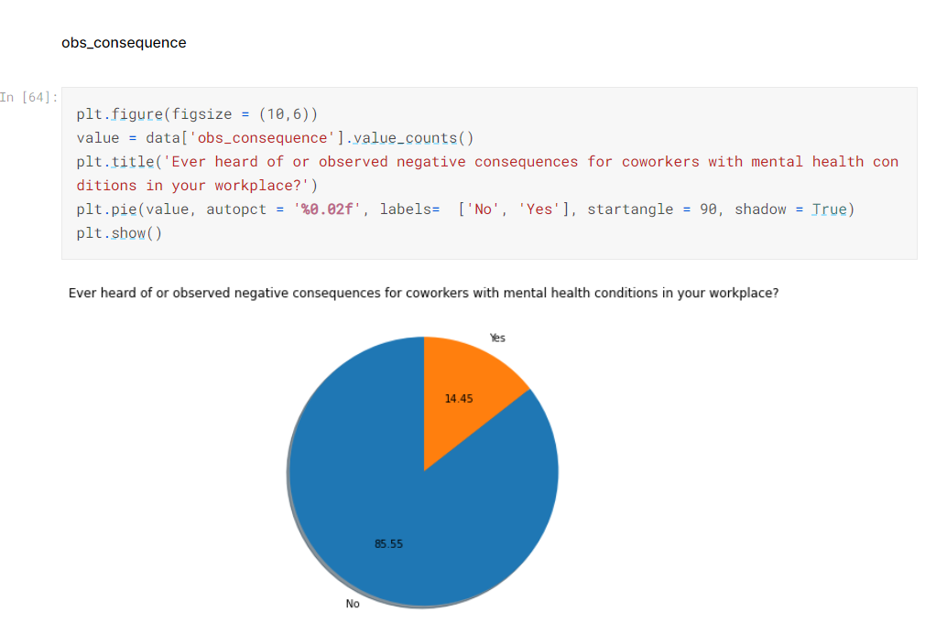

**Mental Health in Tech Survey Analysis Using Tableau Software –**

[DDG-Mental Health Survey | Tableau Public](https://public.tableau.com/app/profile/nisha.pagare/viz/DDG-MentalHealthSurvey/Dashboard1)

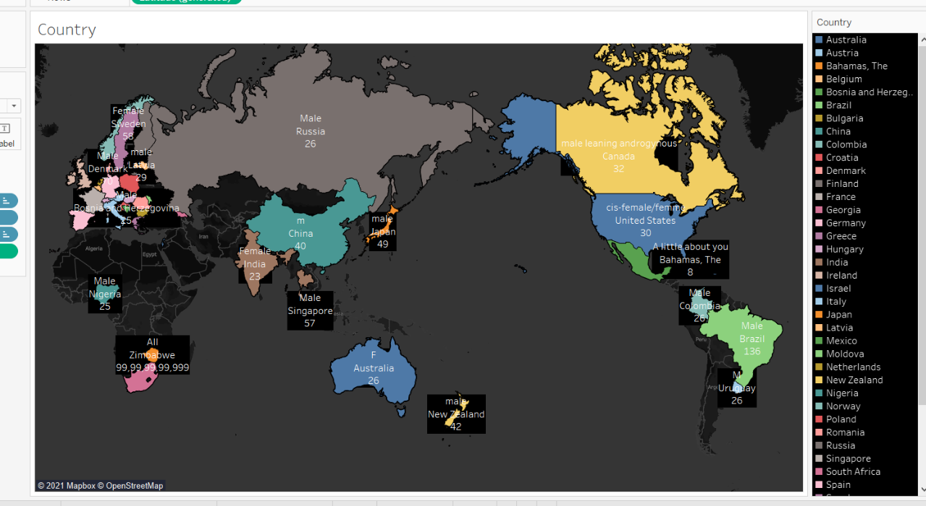

This tableau analysis shows us first sheet that we created country wise gender and age

This map shows country wise and age wise male and female having mental illness.

Highest no: Country – Zimbabwe Lowest no: Bosnia

Gender – All, female, male Gender – male

Age – 99 Age - 25

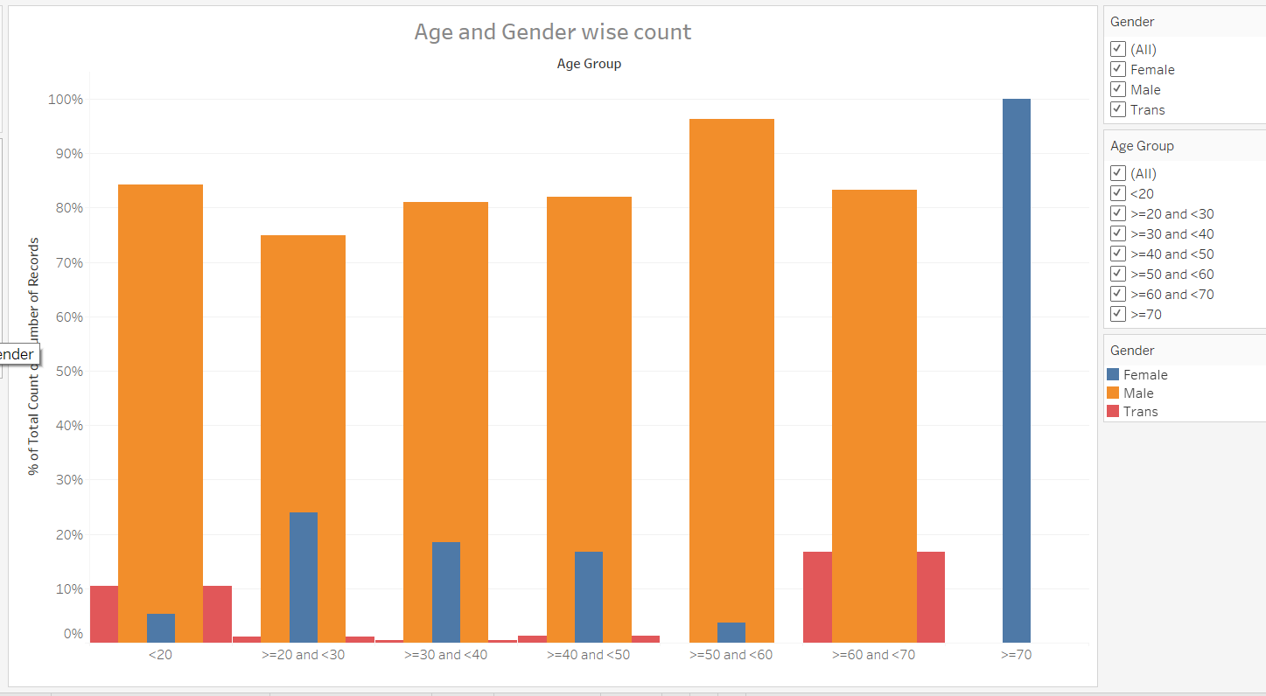

This is second sheet of Tableau software here we used Age and Gender wise count

VS % of total count number of records.

* Highest group is >50 =<60.
* Lowest group is >20 =<30.

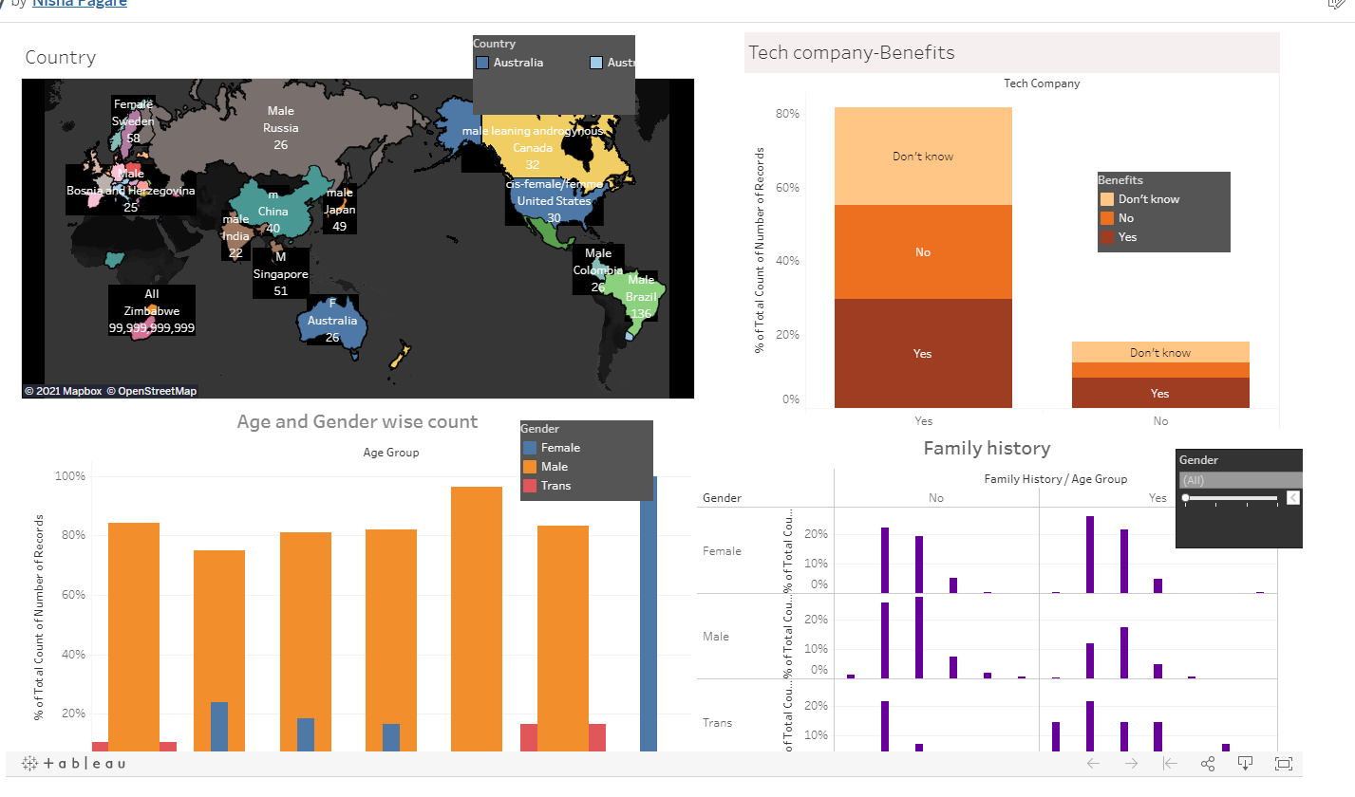

At the end we created this Mental health in Tech survey Dashboard using Tableau software. There are four types of sheets such as Country, Tech company-benefits, Age and Gender wise count and family history.

1 Country – Highest Country –Zimbabwe

Age – 99,999,999,999

Gender – All, female, male

2 Teach company- benefits – highest % of records

Benefits – Yes

Tech company – yes

% - 29.63%

3Age and Gender Wise count- Highest no of group

% total count of number of records- 90%

Group of age - >50 =<60

4 Family history - highest Group

Age group - >30=<40

Family history – no

All records Gender - Female 19.20%

**Here is the Dashboard link we make and connect to Tableau server.**

[DDG-Mental Health Survey | Tableau Public](https://public.tableau.com/app/profile/nisha.pagare/viz/DDG-MentalHealthSurvey/Dashboard1)

**Covid- 19 Survey Methodology and Analysis -**

In the year 2020 Covid – 19 a biomedical disease has serious physical and tremendous mental health implications as the rapidly spreading pandemic.

Conducted by**- Naveen Kumara Raghavendra, Suresh Gopal**

In between June 2, and August 30, 2020. He initially identified 6897 internal migrant workers through a snowball sample method.

About the Datasets-

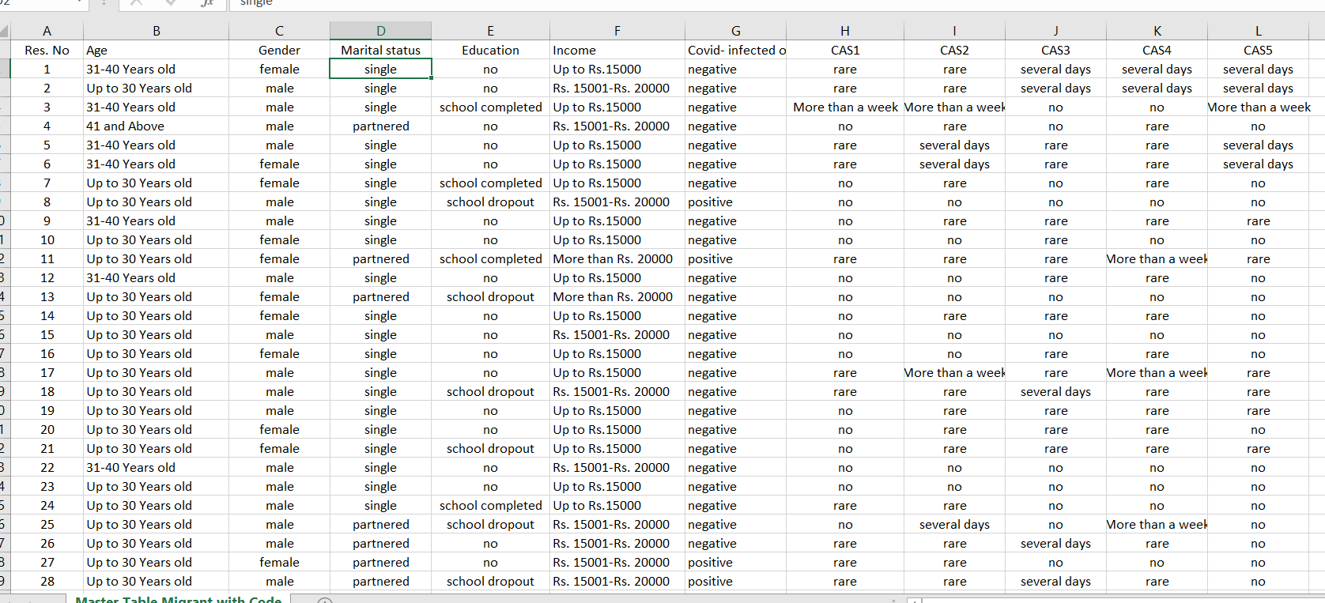

We gathered this information from ScienceDirect research article. to present a paper because of call for paper in the diary named "Movement and wellbeing". We have recorded 1350 reaction out of 6897 Sample through snowball testing strategy. Each respondent is supposed to be official for additional example. The reactions were gathered between June 2 and August 30, 2020 through the telephonic meetings. The meeting plan was embraced by utilizing Corona infection Anxiety Scale (CAS) which utilizes four-measurement model specifically Cognitive, Emotional, Behavioural and Psychological.

**Parameters of data collection** – Respondents the data were chosen based on snowball sampling exclusively it was collected from internal migrant workers across the India the fact is here whether the location was affected by the pandemic or not.

**Description of data collection** - This is Survey which was administered to internal migrant workers between June And August 2020 through telephonic interview from 1350 responses. The interview records the response is below -

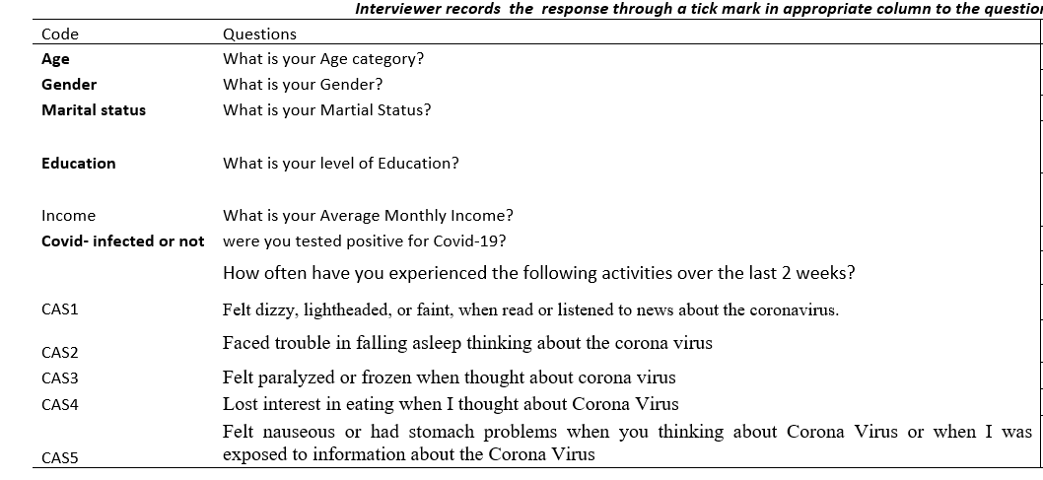

The question response we analysed –

1. - Felt dizzy, Lightheaded, or faint when read or listened to news about the coronavirus.

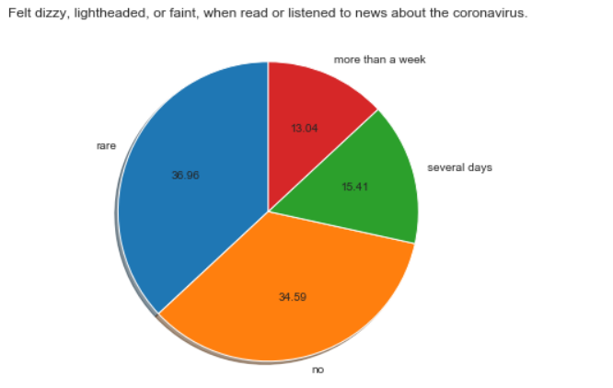

There are 36.96 % people who were feeling dizzy or else if listened to news about corona virus.

13.04% is more than a week

15.41% several days

And there are 34 % people who were feeling nothing dizzy or else when they hear about corona virus.

3) – lost interest in eating when I thought about Corona Virus

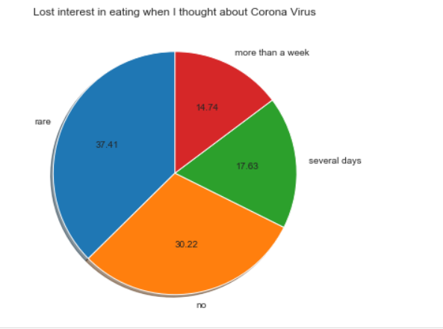

People who were rarely losing their interest in eating- 37.41%

People who were losing their interest in eating for nearly more than week- 14 %.

3 This is chart shown to us in the pandemic, anxiety and thoughts of suicide have increased for many young adults. this survey analysis of the large no of share young adults (Age 18 – 24) have symptoms of anxiety and disorder.

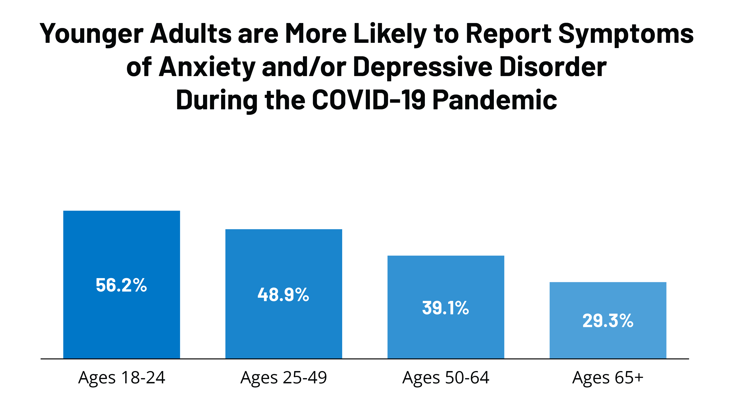

We find that in households adult men and women the difference between both there are 7 to 10 under the women they have negative mental health from pandemic environment total **women 55% and men is 38%** of negative impact on their mental health.

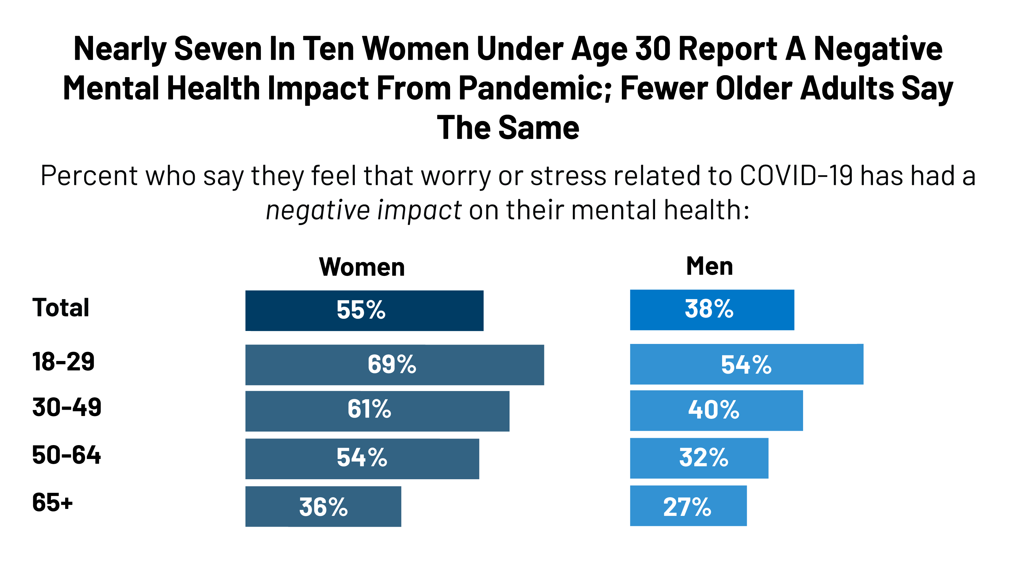

**Impact of Covid-19**

* The pandemic on mental health is complex, diverse and wide ranging, negative impact on all parts of societies and populations was growing. The age category is between 20 to 40 years old and above got affected from covid -19.
* Globally people were infected and existing poor mental health are facing number of risks including their mental health and disruption of Covid-19. People were fearing like what if they might get infected or a family member got infected then what.
* Many have suffered loss of livelihood they business or job. Even those who are working was having fear of losing their job.
* Some of them were facing stress disorder, obsessive-compulsive disorder, anxiety and panic disorders generalised anxiety disorder. The effects on mental health will last and few of several years after the pandemic ends.
* Community-based psychosocial support exercises have likewise been seriously affected with numerous nations seeing gatherings, affiliations and local area based there individuals together consistently before the pandemic circumstances they incapable to meet each other additionally adverse consequence on wellbeing laborers having a significant impact in battling the episode and saving lives.
* The frequency of depression was (50.4%), anxiety (44.6 %), insomnia (34%) and distress (75%).

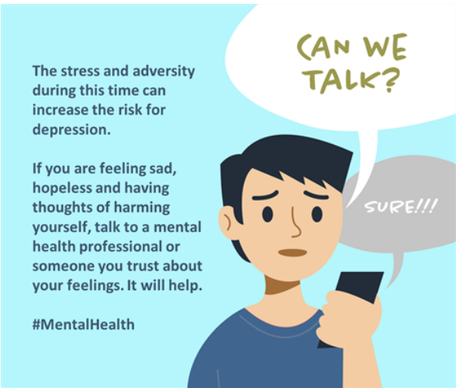

**Discussion and Overview of Mental Health** -



**There remains "little association" between technology use and mental-health problems, a study of more than 430,000 10 to 15-year-olds suggests.**

The Oxford Internet Institute compared TV viewing, social-media and device use with feelings of depression, suicidal tendencies and behavioural problems.

<https://www.bbc.com/news/technology-56970368>

Worldwide, emotional wellness is being tested more than ever by Coronavirus there are numerous vulnerabilities about how the pandemic will advance. Presently the circumstances and computerized gadgets as a type of alleviating pressure and accomplishing advanced reach on whatever issue, for example, emotional wellness is we can take care of this issue through Technology. we notice actual cleanliness to remain well, we need to develop a sort of passionate cleanliness as well.



**1 Mental health Disorder -**

1) Distinguishing Anxiety and Depression -

On the off chance that we have any troublesome opportunity to unwind no on the grounds that you can't stop to pondering things that happened early and what will happen later or before are these indications of uneasiness or wretchedness or simply an absence of rest? how might we talk about this thing – Anxiety and despondency are like each other they can be or may be brought about by same things and can have same indications. So significant is to comprehend what is influencing you and what is demonstrative of.

2) Computer science understudies and psychological wellness assets -

Undergrad Computer Science understudies at exceptionally aggressive establishments, for example, the one at which I instruct, live with huge measure of pressure. Understudies in huge classes may feel like an anonymous face particularly on the off chance that they are individuals from verifiably underrepresented gatherings. Understudies they have strain to land position of top IT organization, MNC organization that is the reason understudies about grounds emotional wellness additionally and state openly that I live with a psychological sickness have embrace issue.

3) Eating Disorders –

The specialists concur they are outrageous level fasting and biohacking just Rebranded Eating Disorders when famous tech VIPs start supporting these kind of outrageous eating designs, it very well may be hard for individuals to see them in anything other than a positive light. By one way or another while eating the food, they not focus on their food what they eat. its dietary problems.

**2 How to Technology help to improve our mental health**

you can't actually contemplate or de-stress adequately with innovation on the since quite a while ago run. Be that as it may, it is an incredible instrument for making the principal strides. It could work also to addictions it very well may be simpler for a mechanical society to find out about contemplation and viable pressure the executives through another computerized device, utilized less and until totally losing it eventually.

1. PIP Device –

It is a little gadget. The combined with cell phone application intended to give prompt criticism about feelings of anxiety. This is application Shows to us Winter picture that the client needs to change into summer

2. Virtual reality treatment -

• VR is a generally new field, yet progress is quick, and it is turning out to be progressively evident that augmented simulation innovation has a significant task to carry out in the field of psychological wellness.

• VR headsets can help desensitize patients experiencing post-horrendous pressure problem, by reproducing their own triggers. This assists them with creating adapting strategies in the protected climate of their own home or an advisor's office. VR can likewise help patients experiencing sadness, uneasiness, and different problems.

3. Mental Health Apps

• There is an application for everything nowadays, from shopping records and banking applications, to applications for efficiency and climate determining. Emotional wellness applications, in any case, have demonstrated to be valuable. The absolute first applications showed up around 2009 and from that point forward, a lot more have been created. Egg – Titoki, social media, application

• Apps can be utilized anyplace, as they are attached to a cell phone as opposed to a work station. This movability makes them extraordinarily valuable, particularly for the more youthful age, who are bound to experience the ill effects of pressure and uneasiness.

• Mental wellbeing and health applications will in general zero in on three key regions: mind-set, stress, and nervousness. Applications go back and forth, as you may expect, yet the most mainstream applications incorporate Calm, Mood notes, Headspace, Pacifica, and Talk space. Investigate those sites and download the applications to your telephone**.**

**4. Help with Anxiety-**

The top-of-the-line App, Calm, is allowed to utilize, in spite of the fact that you can pay a redesign expense on the off chance that you need to exploit every one of its highlights. This application, which was delivered in 2017, helps individuals experiencing uneasiness utilizing guided reflection, breathing projects, and methods to improve care. You can even tune in to loosening up sounds and calming sleep time stories in the event that you are focused and incapable to rest. Pacifica, another helpful nervousness cantered application, is additionally allowed to utilize. This additionally shows care contemplation strategies and has disposition following activities.

Example - Tiktok, Instagram, Spotify etc

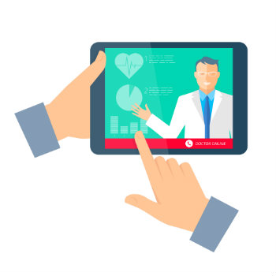

1. **Mood Apps** –

* The top-ranking mood app. If your mood is up and down and you are struggling, downloading mood notes could help you spot a pattern to your mood and boost self-awareness. Mood notes has a mood journaling feature and it helps you to avoid annoying thought traps. The app, which was released in 2015, is not free, but at $ 3.99, it’s very affordable. Daylit is another useful mood tracking app; this one if free to use.
* If you are battling with pressure, don't stress, as there are a lot of applications that can help you discover alleviation. CBT is a best ten appraised application for stress help. The application Which was delivered in 2010, costs $5.90/month to utilize. It utilizes intellectual conduct treatment to change your twisted however designs.
* Its According to national Institute of Mental Health, nearly one five adults in all over world have serious mental illness.

The prevalence of mental health conditions combined with the lack of access to care and more sophisticated technology has stimulated interest in the use of technology to enhance and expand mental health care.

**Benefits of Technology** -

* Although not a panacea for the absence of psychological wellness care, the utilization of innovation can upgrade and extend emotional well-being care in regions, including provincial regions, where suppliers are scant. Innovation may help clinicians in coming too hard to-arrive at populaces because of topographical obstructions or the disgrace related with looking for help.
* The certainty that a few kinds of innovation, for example, applications, are lower in cost than conventional consideration may likewise work with access. Additionally, innovation is advantageous. As the National Institute of Mental Health brings up, treatment can happen in any spot and whenever, day in and day out.
* As with any innovation, there are likewise worries about its utilization. Basic concerns incorporate the need to secure protection, research that shows that innovation fills in just as conventional techniques, and a variety of moral issues. In spite of this, the potential for innovation to help improve emotional wellness care is promising

**What kinds of Technology Exist**? -

Mobile Applications-

There are at present more than 1,000 portable applications dedicated to emotional wellness, with many zeroed in on tension, wretchedness, and substance misuse. Psychological well-being applications permit individuals who are reluctant to look for vis-à-vis administrations discover help, regularly secretly. Versatile applications likewise permit specialists and emotional wellness experts to screen progress and treatment adherence. Albeit these applications have extraordinary potential, there is next to no guideline of psychological wellness applications or examination on their adequacy. Be that as it may, they can regularly be a decent initial step for the individuals who have kept away from emotional well-being care before.

At present, applications exist for:

• Self-the board: client adds data, so that the application can give input (i.e., medicine updates).

• Thinking abilities

• Skill-preparing: assist clients with mastering adapting or thinking

abilities; frequently set up like games.

• Illness the board, upheld care: permit clients to get extra help by associating with another individual.

• Internet-based care groups-

Care groups, like Big White Wall, given a choice to people who like to stay unknown in getting to emotional well-being treatment or who can only with significant effort access treatment during customary working hours. Notwithstanding secrecy and nonstop assistance, these locales frequently offer instructive assets and may offer freedoms for individuals to converse with each other.

• Telehealth

Telehealth is innovation that permits a person to talk with a medical services supplier through telephone or video visit. Telehealth can be useful for psychological well-being treatment since it lessens expenses of administrations and improves admittance to administrations for the individuals who can't see an emotional well-being proficient face to face.

• Virtual reality

Augmented reality is moderately new; notwithstanding, it is quickly getting significant in the field of psychological well-being. As Digital Health Today reports, computer generated reality headsets can "help desensitize patients experiencing post-horrendous pressure problem, by reproducing their own triggers. This assists them with creating adapting methods." This innovation can likewise help patients experiencing discouragement, uneasiness, and different issues

User mental health technology

Tips for individuals thinking about using technology

Ask a confided in supplier for a suggestion.

• Find data on the accreditations and experience of the application developer(s).

• Turn to the writing to check whether there are any observational distributions on the innovation.

• Determine if the application depends on an exactly upheld treatment, as Cognitive Behavioural Therapy

Tips for suppliers considering utilizing innovation

• Remember that innovation is still generally new, so get your work done. What are the chances for utilizing innovation to enhance customary consideration? What are the impediments?

**•** Think about how you'll connect with patients.

• Implement severe quality controls to guarantee information protection and security.

• Develop conventions for taking care of crises.

**Mental Illness –**

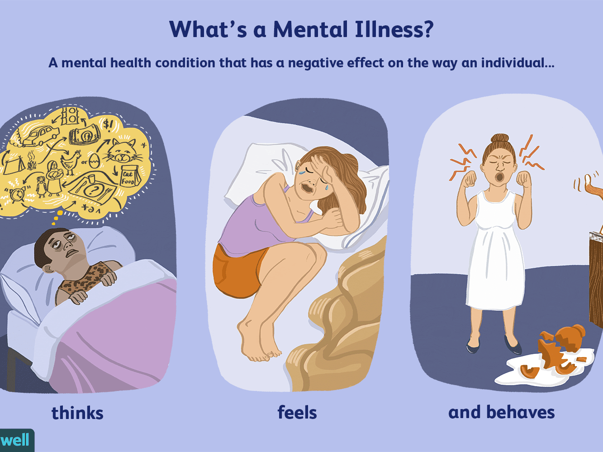

The Mental disease are regular in the United States and India or we can say all over India almost one of most live Adults with a psychological instability close around 55 Million out of 2019. This incorporates various conditions that differ in level of seriousness, going from gentle to direct excessively extreme. Two general classifications can be utilized to depict these conditions.

• Any psychological instability (AMI) – this is incorporating all perceived dysfunctional behaviours.

• Serious dysfunctional behaviour (SMI). – is a more modest and more worker subset of AMI. Expansion data on dysfunctional behaviour can be found on the NIMH Health.

• Any psychological sickness (AMI) is characterized as a psychological, social, or enthusiastic issue. AMI can shift in sway, going from no impedance to gentle, moderate, and surprisingly extreme hindrance (e.g., people with genuine dysfunctional behaviour as characterized underneath).

• Serious psychological sickness (SMI) is characterized as a psychological, conduct, or enthusiastic issue bringing about genuine utilitarian debilitation, which significantly meddles with or restricts at least one significant life exercises. The weight of dysfunctional behaviours is especially thought among the individuals who experience handicap because of SMI.

Commonness of Any Mental Illness (AMI)

• Figure shows the previous year predominance of AMI among U.S. grown-ups.

o in 2019, there were an expected 51.5 million grown-ups matured 18 or more seasoned in the United States with AMI. This number addressed 20.6% of all U.S. grown-ups.

o the predominance of AMI was higher among females (24.5%) than guys (16.3%).

o young grown-ups matured 18-25 years had the most elevated commonness of AMI (29.4%) contrasted with grown-ups matured 26-49 years (25.0%) and matured 50 and more established (14.1%).

o the commonness of AMI was most elevated among the grown-ups announcing at least two races (31.7%), trailed by White grown-ups (22.2%). The commonness of AMI was most reduced among Asian grown-ups (14.4%).

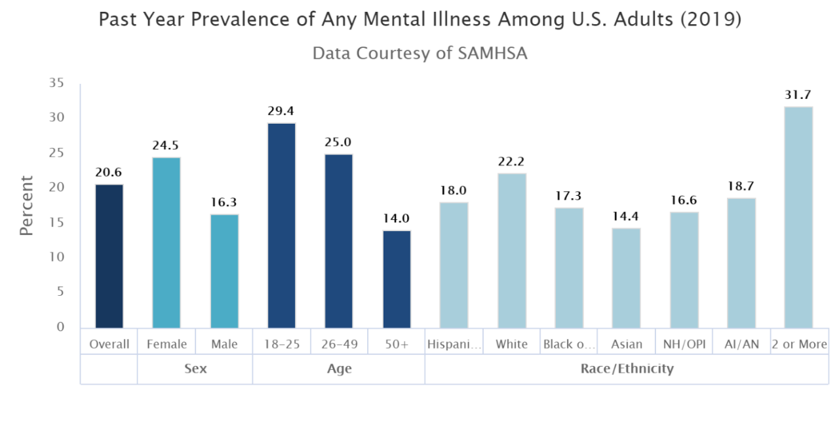

**Description of the Survey**

Mental health in the workplace is increasingly important for employees in the technology sector. Mental illness is the leading cause of sickness absence and incapacity benefits in most high-income countries (Harvey et al., 2009). Poor mental health can lead to losses in productivity, performance, actual jobs, and a decline in well-being. Without receiving proper treatment and assistance at work, employees can suffer greatly. Companies would be able to invest in their employees if they could provide them with the appropriate mental health resource.

For employees, their productivity can be regained, mental health can be improved, and quality of life can increase, by obtaining the correct assistance in their workplace yet limited research to date has explored this relationship. As such, this study and its findings are crucial. Furthermore, the technology-sector is also heavily dominated by men, with only 25% of all computing jobs held by women. This number shrinks significantly when taking race into account, with Black and Latina women holding 1 and 3% of these jobs respectively (Ashcraft et al., n.d.). There are a disproportionate number of women in this field who are subject to more stress and discrimination, which can adversely impact their mental health and well-being. Technology companies.

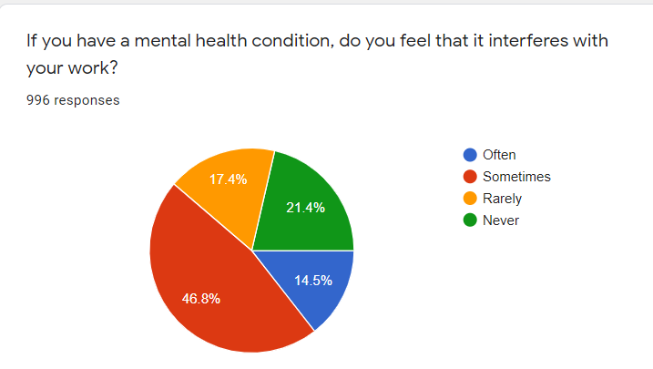

Often: 15%

Sometimes: 49%

Rarely: 17%

Never: 21%

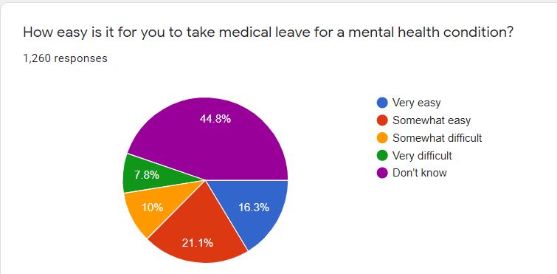

Very easy: 16%

Somewhat easy: 21%

Somewhat difficult: 10%

Very difficult: 8%

Don’t know: 45%

The results from this study conclude that employees of primarily technology-based companies or organizations compared to those working for companies or organizations of other designations face greater hardships when trying to discuss mental health issues at the workplace. The results from the generalized linear models revealed a few key observations. When modelling if employees were willing to discuss mental health issues with their direct supervisors who worked at technology companies or organizations, they were in fact more likely than those who don’t. Controlling for gender also revealed that men in these organizations were more likely to discuss these issues with their supervisors than women, highlighting a gender difference in willingness to discuss mental health issues with an employee’s superior.

Another key finding from this series of models, albeit not surprising, was that employees were more willing to discuss mental health issues with their supervisors in environments where it's easy to take leave for mental health issues regardless of other controls. When modelling if employees believed they would face negative consequences for raising mental health issues at primarily technology-oriented companies or organizations, they were more likely to believe they would face these negative consequences compared to those in companies with varying orientations. When controlling for demographics, family history of mental health, if the employee received mental health treatment, and working in Asia, were found to be statistically important factors. When additionally controlling for the employer’s mental health resources, the types of resources available, demographics, and working in Europe and Asia, were the top driving factors, regardless of what type of company you’re employed with. Remote work status and self-employment were never found to be significant in either series of models.

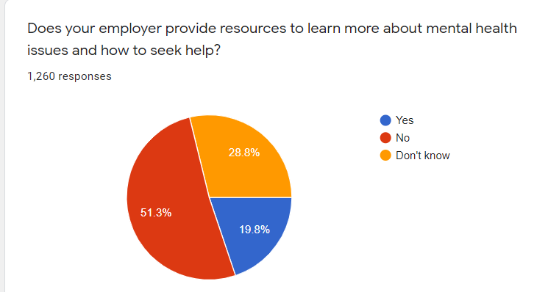

Employer mental health – yes 19 %

Mental health – no 51%

Don’t know – 28%

Following Survey chat show us Physical health issues of employee for a well operating workforce where employees’ mental health is considered, employers need to have the right resources available and treat mental health with as much priority, if not more, as physical health. However, studies performed on this topic focus on the general workplace. The technology sector is growing rapidly in size and in influence. Just within the United States alone, computer and information technology occupations are projected to grow 12% from 2018 to 2028, adding 546,000 jobs which is a rate much higher than the average for all occupations. With such a large industry employing millions of people, a strong focus should be 1 placed on understanding mental health and providing the right benefits to those who are dealing with mental illnesses.

In the below shown figures we try to find who free a person feels to share his/her physical or mental illness with his/her employer, co-workers and direct supervisor

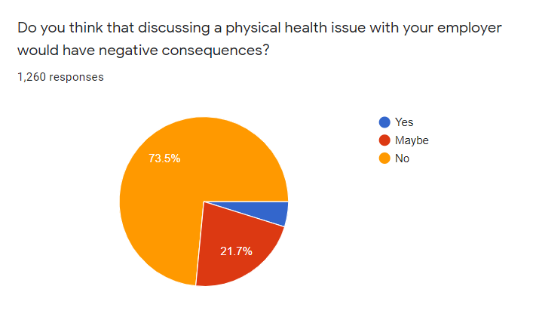

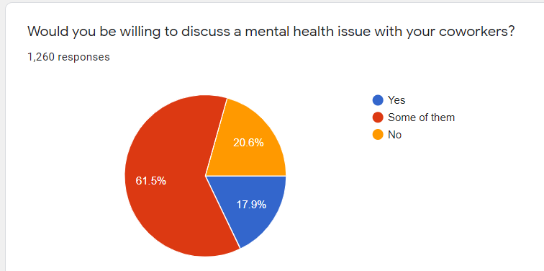

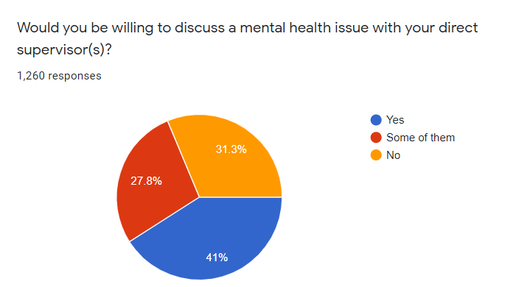

**This last chart of show us if employee tell yes then what % of your worktime is affected by mental health issue – there are 1-25% there is primary and secondary job fun.**

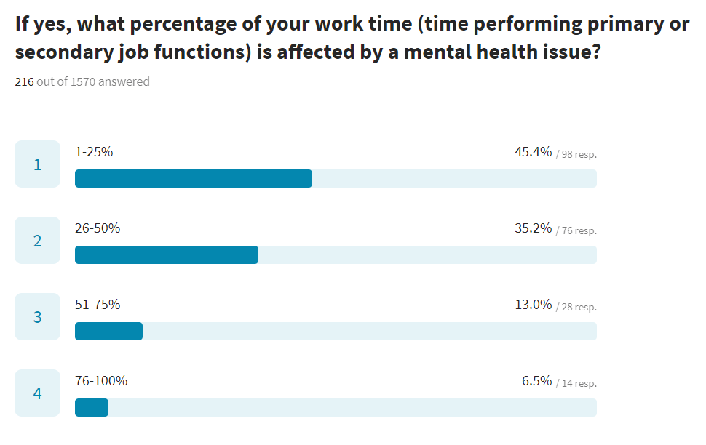

**Role of policy recommendation -**

From the above analysis and visualisation, the Government of India should constitute a Policy Groups to recommend a mental health policy for the country which needs to satisfy certain goals and objectives which are mentioned below

**Goals:**

The goal of the government was to prevent mental illness, enable measures to recovery people from mental illness, stop stigmatization and desegregation and provide accessible, affordable and quality health service for the people who were affected by the mental illness

**Objectives**

Few objectives that the government of India should keep in mind before amending the policies are:

Equity: policy should not be amended with equality but should be amended with equity since the nation in built diverse people with diverse social and economic status. The vulnerable and the excluded people of a community should also be able receive services when they are in need.

Quality: the quality of the service should not vary to person to person every person in the society should receive the same health care treatment.

Governance and effective delivery: Before the national government making the policies for the nation it should have deep discussion with the sub governments such as panchayats, municipalities and state government since they deal with smaller section of the people in the society, they know what polices would be best for the people in that society.

Justice for all: every person in the society should receive the same amount of health care.

Maintenance of the sector: the government or the sub-governments should have to make a routine visit to the respective health care institute to make sure everything is going well

**Policy process**

Health policy at the national level can determine the vary of health, morbidity, disability, and mortality problems it intends to tackle, the relevant settings coated by the policy, the framework for implementing policy within the relevant settings, including, as an example, health services, social services, the education sector, the geographic point, and therefore the criminal justice sector. The policy could launch desired goals and can set a framework for coming up with at the native level.

The policy process that should be considered under different administrative level:

* Firstly, the national parts embrace the development of a national strategy to market psychological state, cut back morbidity and cut back mortality; the institution of policy links with alternative government departments, as well as home affairs, criminal justice, education, housing, finance, etc.; the inaction of specific psychological state legislation (to set the philosophy of approach to the care of individuals with mental disorders in conjunction with precise provision for assessment and treatment while not consent underneath sure outlined conditions, within the interests of the individual and therefore the public and with relation to safeguarding human rights); finance (to take away perverse incentives, to make sure property native finance, and develop funding streams for dispersive smart follow models); implementation plans and overall system of responsible and governance.
* Secondly way that the adjunct infrastructure elements embody an individual's resources strategy, a shopper involvement strategy, a research, and development strategy, and a psychological state info strategy (which ought to embody context, needs, inputs, processes, and outcomes).
* Thirdly, the service parts embrace medical aid, specialist care, the links between the 2, sensible follow pointers, liaison with NGOs, police, prisons, social sector, dialogue with ancient healers, mental state promotion in faculties, workplaces, and therefore the community.

The views of service users and carers will be particularly important, as they will be directly affected by the strategy and will have personal experience of the problems in the current system. They will also be able to comment on those aspects of the current mental health system that are working well.

**Mental health policy needs to be linked in with generic health policy.**

* The mental health policy needs to be linked in with generic health policy. It is particularly important that any general public health strategy addresses mental as well as physical health, so that national mortality indicators include death from suicide - with attention to enhancing the accuracy of recording of suicides, so that national morbidity indicators plan to include relevant measures of morbidity due to mental illness; and so that any health impact assessments, explicitly include mental health.
* Some of the generic health policy issues that will impact on mental health include primary care funding, training and incentive arrangements, and government generic health targets.
* It can be helpful to ensure mental health is included *in*generic health reforms that are occurring, such as development of health information systems, hospital optimisation programmes, quality standards, basic training standards, accreditation procedures.

**Conclusion**

While working on this project we were completely focused on the topic that is mental illness, and as it has become a need to communicate about mental health openly to understand a person like what and how he is feeling whether he/she is going through any mental illness like anxiety, feeling dizzy, feels often disinterested or stressed. Also, because today every thing has became digital more and more work load is headed towards technical industries and from technical industries towards its employees. So, while doing analysis of OSMI survey we came to understand that multiple mental health issues mostly occurred under age of 25-40. We also got to know that not much employees share their issues in any wellness program conducted by companies.

We also analysed covid-19 survey conducted in June-August 2020 and came to understand that during lockdown period many people lost their jobs which was the main reason behind their mental illness, many people faced mental health challenges like often feeling disinterested, feeling anxious whenever he/she listens any bad thing related to covid-19.

But for those people who don’t share their issues for such people software developers(technology) have created many applications like help with anxiety, mood apps, PIP device (give immediate feedback about stress levels) which might help them. We learnt government policies made for people facing mental health challenges, what all points should be kept in mind while making or processing any policy.

**References –**

**1** By Jennifer Apulian, PhD., Joe Ferguson, ED Finkler

[**https://osmihelp.org/research**](https://osmihelp.org/research)open-source mental illness LTD is non-profitable Indiana corporation with 501© dedicated to raising awareness, educating, and providing resources.

**2** Artificial Intelligence marketplace.

<https://www.aimlmarketplace.com/technology/data-sets/list/mental-health-in-tech-survey>

**3** Merikangas KR, He JP, Burstein M, Swanson SA, Avenevoli S, Cui L, Benjet C, Georgiades K, Swendsen J. Lifetime prevalence of mental disorders in U.S. adolescents: results from the National Comorbidity Survey Replication--Adolescent Supplement (NCS-A). *J Am Acad Child Adolesc Psychiatry.* 2010 Oct;49(10):980-9. [PMID: 20855043](http://www.ncbi.nlm.nih.gov/pubmed/20855043/)

3 Substance Abuse and Mental Health Services Administration. (2020). Key substance use and mental health indicators in the United States: Results from the 2019 National Survey on Drug Use and Health (HHS Publication No. PEP20-07-01-001). Rockville, MD: Center for Behavioral Health Statistics and Quality, Substance Abuse and Mental Health Services Administration. Retrieved from <https://www.samhsa.gov/data/sites/default/files/reports/rpt29393/2019NSDUHFFRPDFWHTML/2019NSDUHFFR1PDFW090120.pdf>.

4 Joshua A. Gordon, M.D - National Institute of Mental Health <https://www.nimh.nih.gov/health/statistics/mental-illness#part_154910>

5 “Let us recognize that there can be no health without mental health.”  -U.N. Secretary General Ban Ki-moon (2008) Gobal Aliiance of Behavioral Health and Social Justice / USA

<https://www.bhjustice.org/technology-and-mental-health>

6 Dr. John Torous,    
Codirector, Digital Psychiatry Program at the Beth Israel Deaconess, Harvard Medical School

<https://www.newamerica.org/future-tense/events/future-mental-health-technology/>

7 [National Center for Biotechnology Information](https://www.ncbi.nlm.nih.gov/), [U.S. National Library of Medicine](https://www.nlm.nih.gov/)8600 Rockville Pike, Bethesda MD, 20894 USA

[Policies and Guidelines](https://www.ncbi.nlm.nih.gov/home/about/policies.shtml)

<https://www.ncbi.nlm.nih.gov/pmc/articles/PMC1525068/>

